Calculus 3 Lecture 13.3: Partial Derivatives (Derivatives of Multivariable Functions)

What does the derivative of a multivariable function look like?
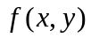 is a surface in R-3 (3-D)

Is a derivative of a mulitvarible function give the slope of the tangent on a surface at a point?
- Too ambiguous number of tangents

To find the slope of the tangent line to a surface at a point, we must give the tangent line a direction.
Fully directional derivatives come in future lesson.
For now, we restrict our direction to:
- The ‘X’ direction or
- The ‘Y’ direction

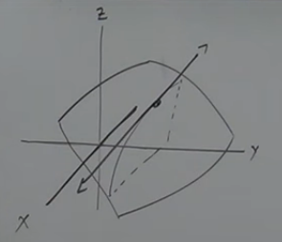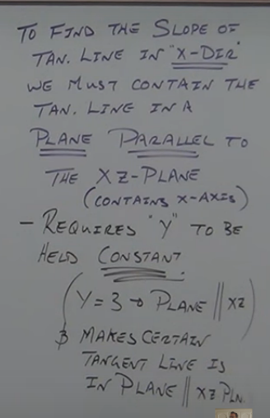
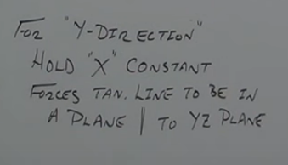
The Idea of treating a variable as a constant and thereby insuring that the tangent line is in the direction of the other variable is called a “Partial derivative”.

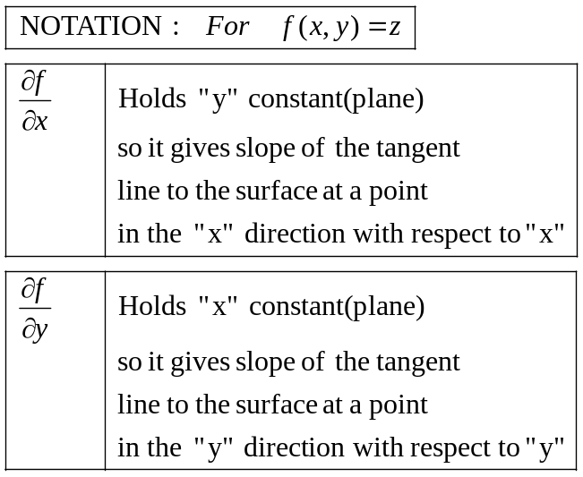

NOTE
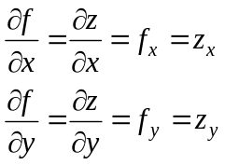

Example
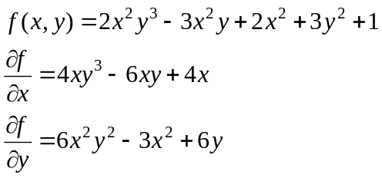

Example
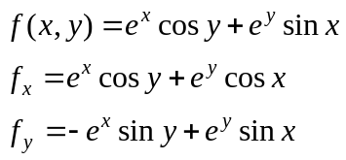
Example
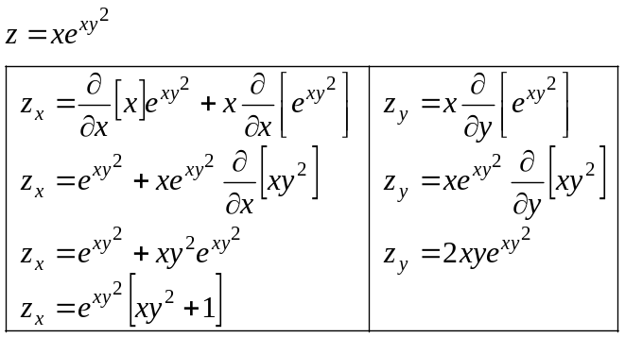

Example
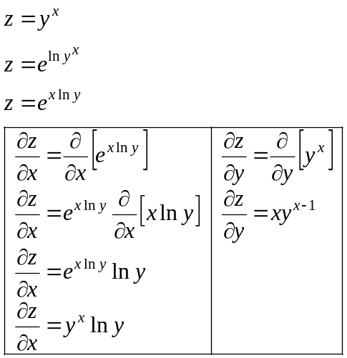

Example
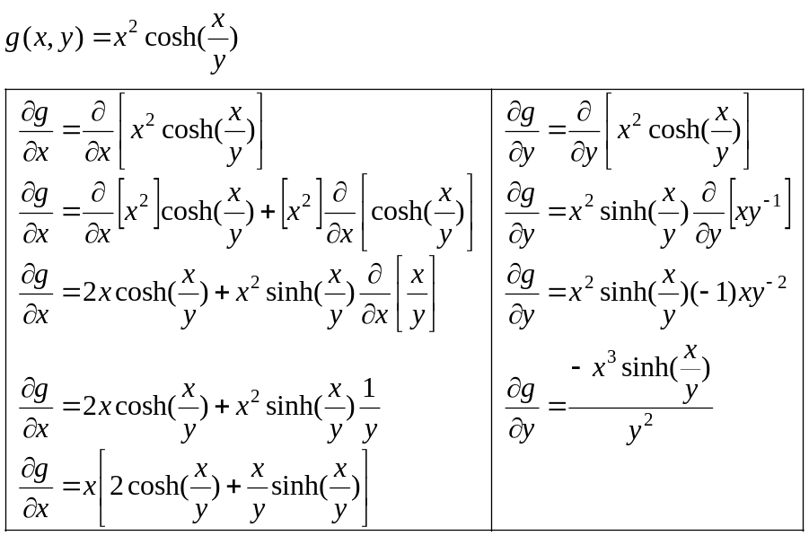

Example
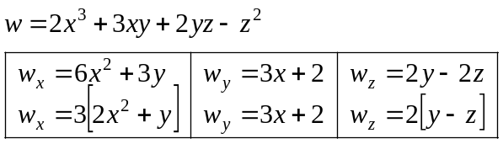

Example
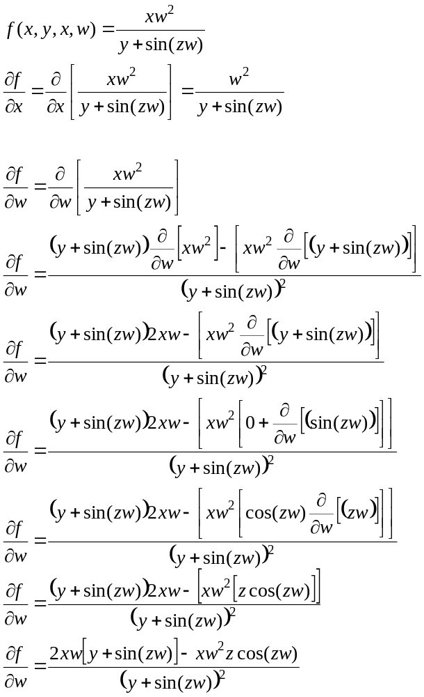

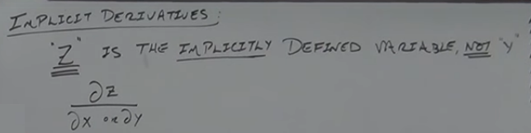
Derivatives happen on both sides of the equal sign.
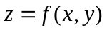 z is defined with both x and y’s so a product rule is required
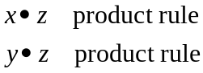

Example
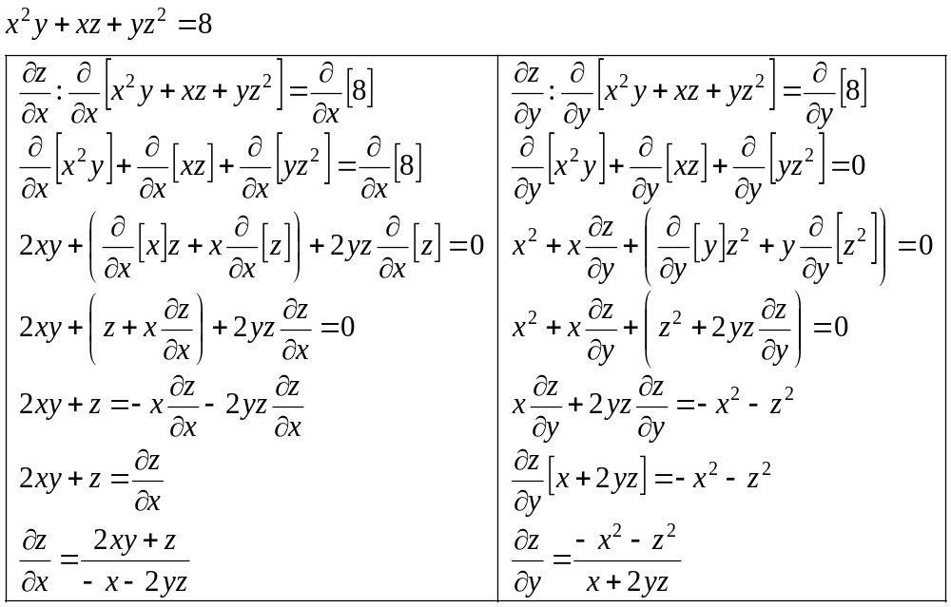
Example
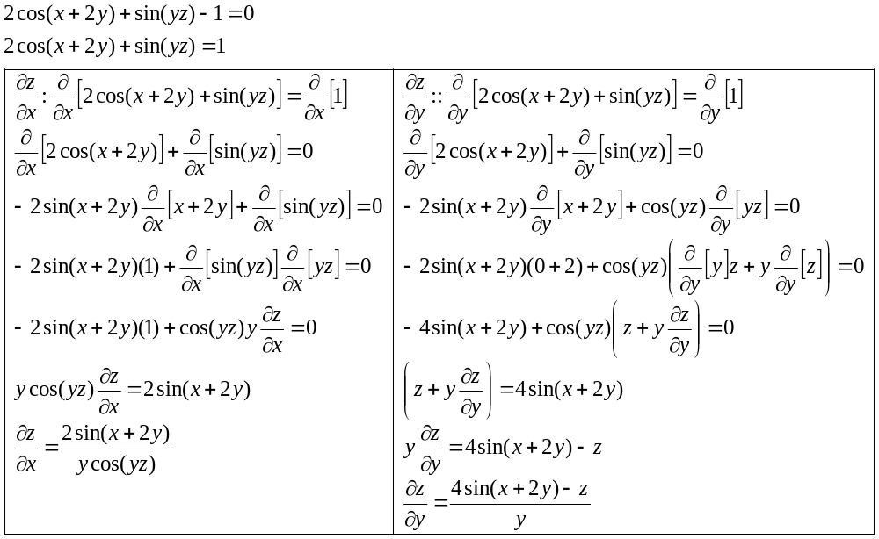

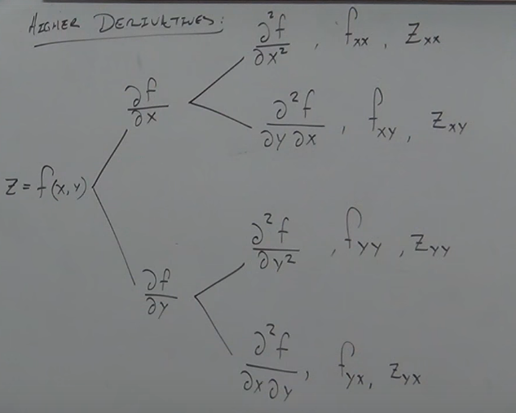

Example
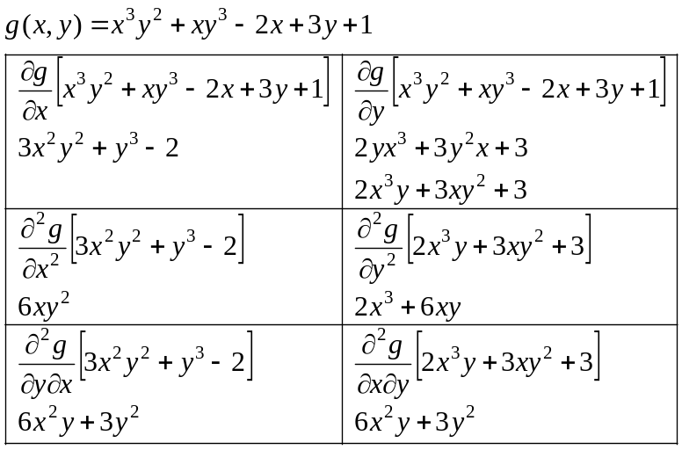

Example
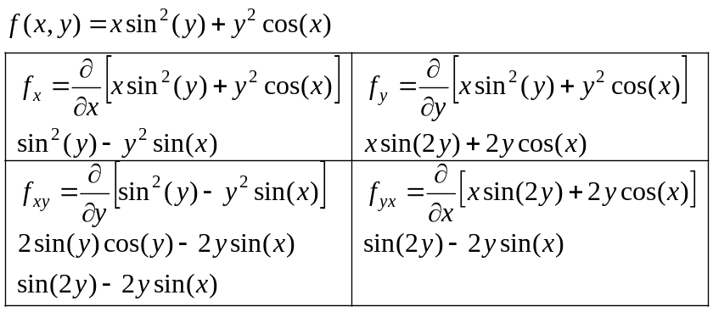
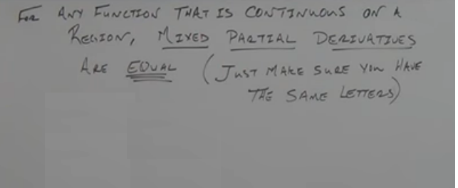
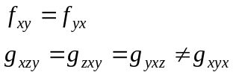

Example
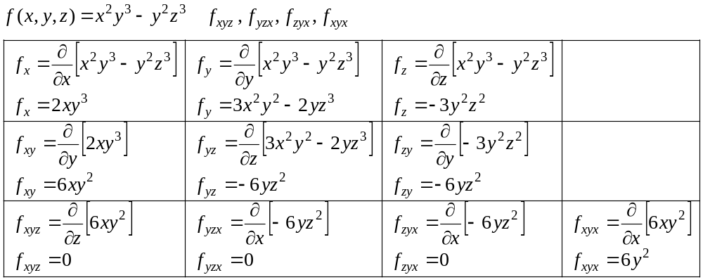

Example
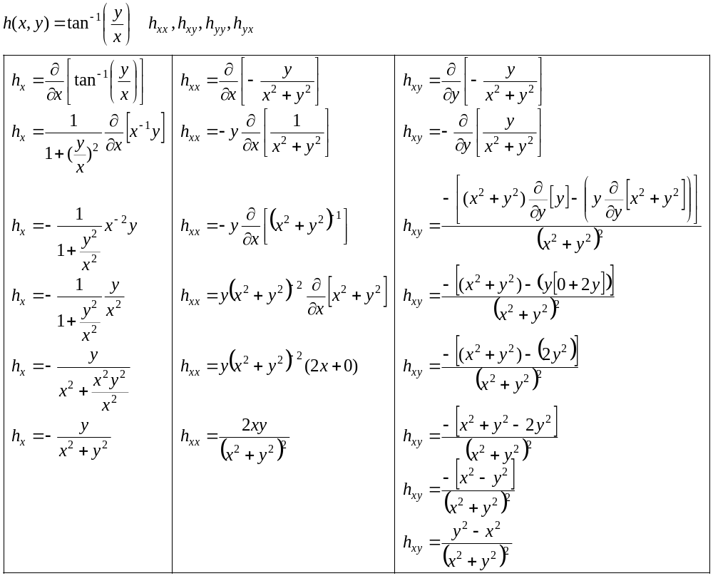
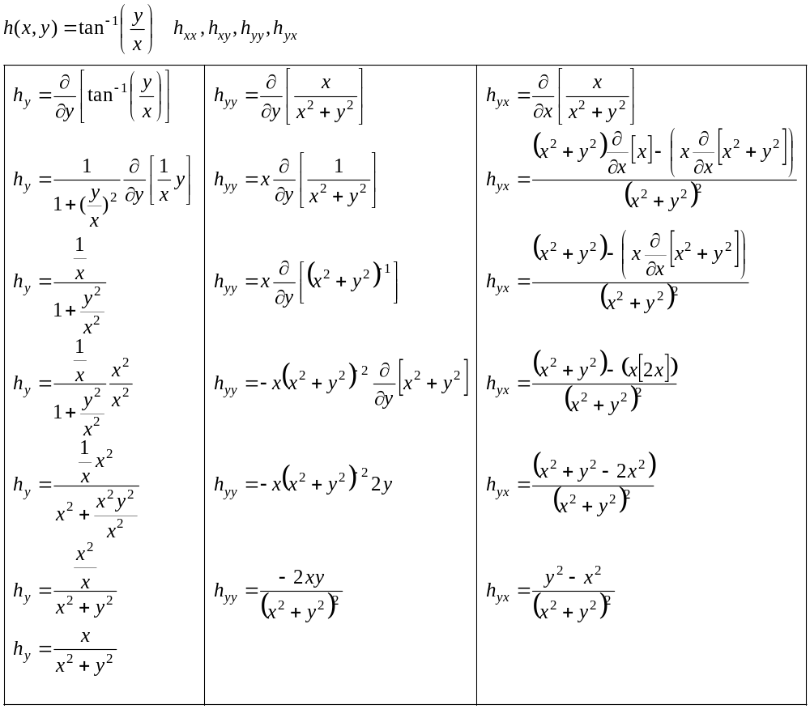

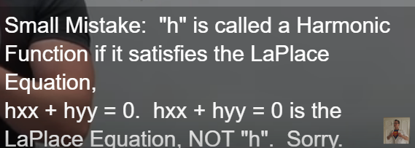
Example
The surface area of a human in 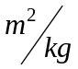 approx. by
